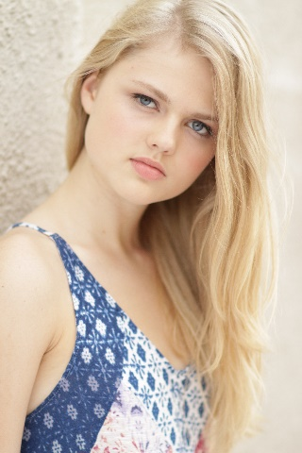
ERIKA JACOBSEN

erikahjacobsen@gmail.com
(206) 409-5753

Height: 5’7’’ Eye: Blue Hair: Blonde Vocal: M. Soprano

Performance
Cats Featured Dancer Roosevelt Theater (WA)
No No Nannette Featured Dancer Roosevelt Theater (WA)
White Christmas Featured Dancer Roosevelt Theater (WA)
So You Think You Can Drag Featured Dancer New World Stages (NYC)
Play Write Project Lead Actress Seattle Repertory Theater
Oh, What a World Dancer Choreography: Cherice Barton
Accentuate The Positive Dancer Choreography: Lauren Gaul
In The Mood Dancer Choreography: Rhonda Miller
Sign of Times Dancer Choreography: Aaron Gordon
WTF Dancer Choreography: Liana Blackburn
All Nite (Don’t Stop) Dancer Choreography: Helene Phillips
Sax Dancer Choreography: Brian Friedman

Print
Free People Seattle Model Amy Helmuth

Choreography
Honors Club Choreographer All That Dance

Education/Training
Pace School of Performing Arts: Commercial Dance BFA Candidate 2016
BDC Professional Semester
LA Pace Dance Intensive w/ Mandy Moore

Special Awards
National Honor Society of Dance Arts
International Thespian Society

Special Skills
Acting, Singing, Taping, Seattle Driver’s License, Passport, Speaking Spanish, Some Aerial Skills, Yoga, Pilates

